

Public Tracking System

Table of Contents

Introduction 3

Department 6 4

Invoiced & Confirmed 5

This Week Lineup 5

Possible for the Week 5

Open Cycles 5

Prospects 5

Partially Paid 5

View Day, Fdn or Combined 5

Schedule a Payment 6

Schedule a Reg Interview 6

Schedule for Resign 6

Account Total 7

Past Invoices 7

Archive the Week 8

Setup Registrars 8

Income Report 9

Registrar Report 10

Service Call-in Committee 11

In and Started 12

Archive the Week 12

In and Started Report 12

Comp Resign 13

Archive the Week 13

Comp Resign Report 13

Bodies In The Shop 14

Archive the Week 14

Bodies in the Shop Report 15

# Introduction

The purpose of the Public Tracking System is assist staff members to efficiently move the Public onto and up the Bridge through application of Admin Know How Series, 33, 34 and 35.

“A product officer has to name, want and get his products.” (LRH, HCOPL PRODUCT OFFICERS)

The system is accessed by clicking on the Public Tracking System icon on the desktop. (If you do not see this on your logon, sign out and then sign back in.)



There are different modules that track public in different parts of the org.

Each module has a the current statistic and what was the total last week as well as a Daily Graph showing this week compared to last week.

At the bottom right of each module you can view graphs related to that module as well as the log that tracks the public.

You can also access each of these modules by using the sidebar on the left.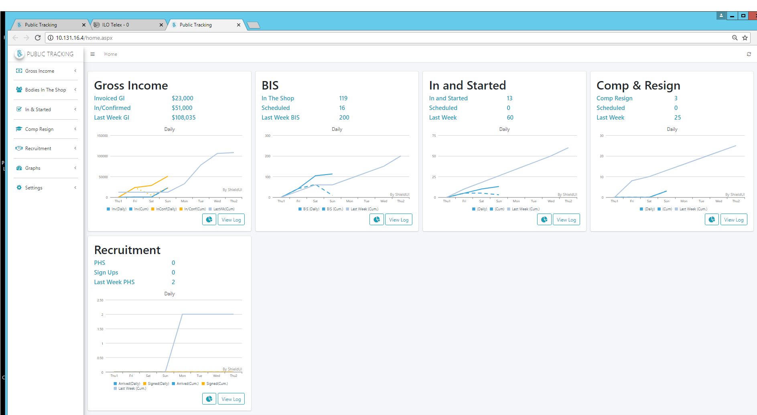

Different areas of the org have access to different modules.

# Department 6

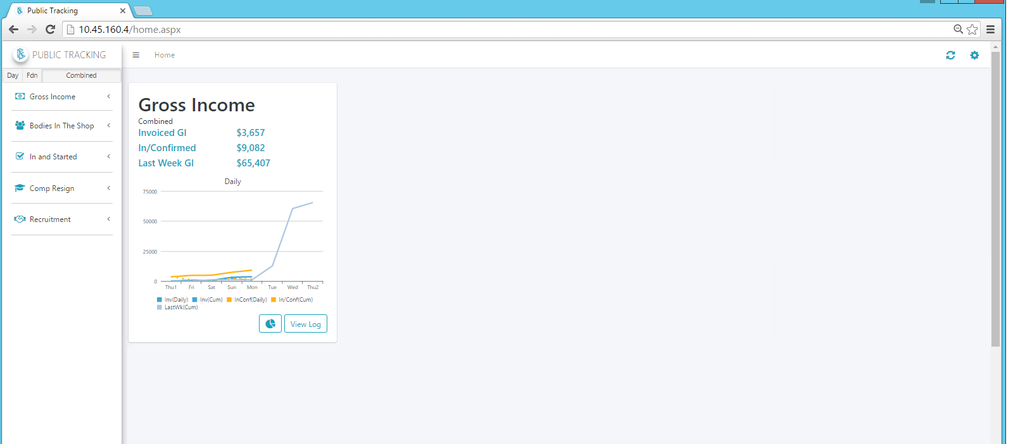

The Department 6 module was created to put control in on the org’s income and ensure all procurement avenues are being utilized to increase production. Most orgs had different ways to track their income lineups and many times, public who should pay for their services were being forgotten due to registrars going down the DEI scale into “Unknown” on their public, or simply due to out-admin.

This system tracks every public who was interviewed and allows you to keep them in sight and stay on the DEI scale at “Interest” until they are paid in for their service. This allows you to do an Income Line Up based on each of the procurement lines in the org.

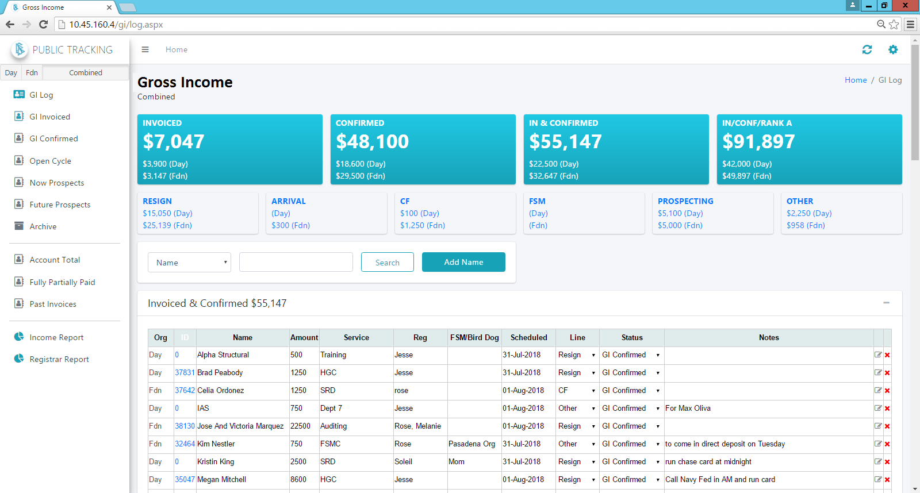

At the top of the Department 6 log you can instantly see where the income stands for the week. This shows the combined total as well as the day and foundation totals. Just below the totals you can see a summary of how much is Invoiced and Confirmed for each of the procurement lines.

You can filter the GI Log by procurement line by clicking on that section. This allows you to see what is named out for each line and ensure you are maximizing the potential from each area.

## Invoiced & Confirmed

“Invoiced” is the income that has come in that week and has been invoiced into the org’s finance computer system.

“Confirmed” is income that has been closed and where the funds have been fully worked out how they are going to be invoiced that week. It is not for “really good cycles that you know you can get done”. It is not for people that are closed who are “working out the funds”. It is only for those scenarios where the money is enroute, credit card or loan is approved and the money will arrive in the org’s account that week. No further handling is required on “Confirmed” income, just 8C to ensure the funds actually arrive in the org’s account so they can be counted as Gross Income for the week.

## This Week Lineup

Your Income Line Up would be entered in the section called “This Week”. This is for everyone that you have fully named out and worked out how it will get done that week. It is not just a list of ideas, but the exact named products that you have named out and figured out how to get done that week.

## Possible for the Week

This is for any named out product that could get done, but has not yet been fully worked out. It is only for those names that you feel could possibly get completed that week. Each of these needs to be fully worked out how it will get done at which point it would move up in status to “This Week Lineup”.

## Open Cycles

This category is for every public ever started on the DEI scale from a reg interview who have not yet been closed. Registrars need to “stay at interest” on each one of these cycles until they are gotten the service they need. When a registrar feels that a public in this category could be gotten done that week, their status is changed to “Possible for the Week”.

## Prospects

The next category is for prospects gotten from FSMs or from asking winning public who they think should be on services. It is not for anyone who has been contacted and is on the DEI scale.

## Partially Paid

The final category is for all public who are partially paid for services at your org. This includes anyone who has less than $2500 on their org account.

## View Day, Fdn or Combined

There is an option in the log to view both Day and Foundation together or to view only Day or Foundation separate. Do this by clicking the ***Day***, ***Fdn*** or ***Combined*** button in the sidebar.

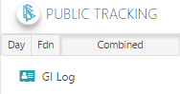

## Schedule a Payment

The log has a column where you can schedule a public when they agree to make a payment in the future. Choose a date from the calendar that pops up when you click in the ***Scheduled*** field and choose “Payment” when you click in the ***For*** column.

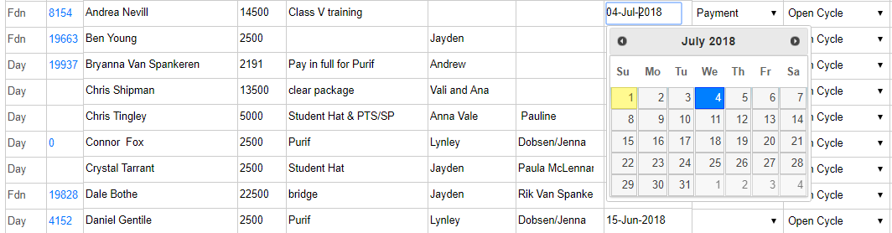

## Schedule a Reg Interview

Appointments for Reg interviews can be scheduled here as well. Choose the date of the interview under the ***Scheduled*** column and then choose “Reg Int” under the ***For*** column.

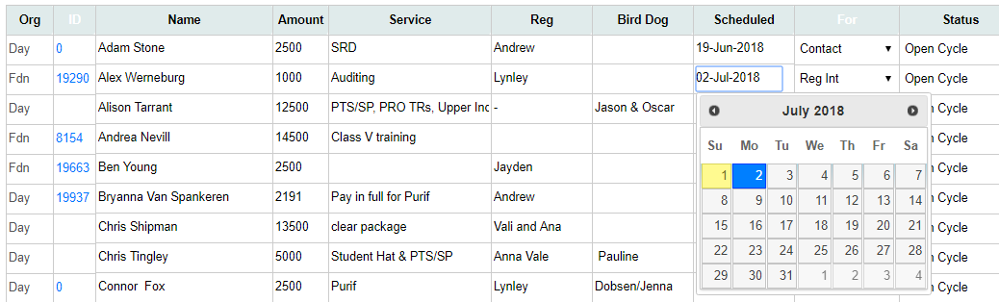

## Schedule for Resign

Get in prediction on when a public will need to see the reg for resign by setting the estimated date of resign under the ***Scheduled*** column and select “Resign” under the ***For*** column.

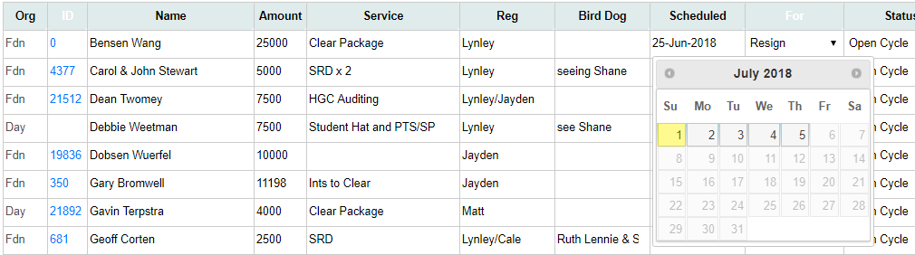

## Account Total

Here you can see the total amount of money each public has on their account. This pulls data from the org finance computer. You can add someone to the lineup directly from this screen.

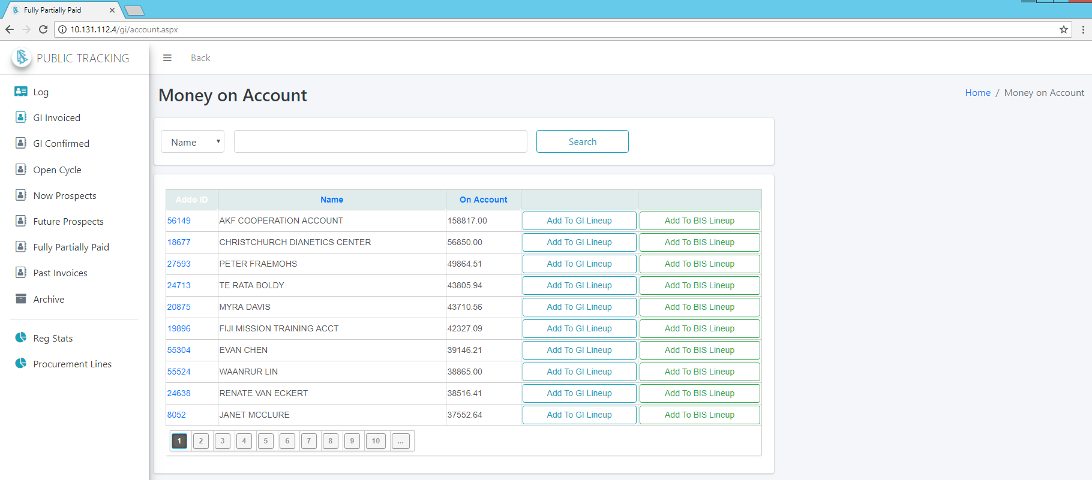

## Past Invoices

This shows all past invoices that exist in the org’s finance computer system. Here you can research past invoices and do analysis and find prospects to add to your lineup.

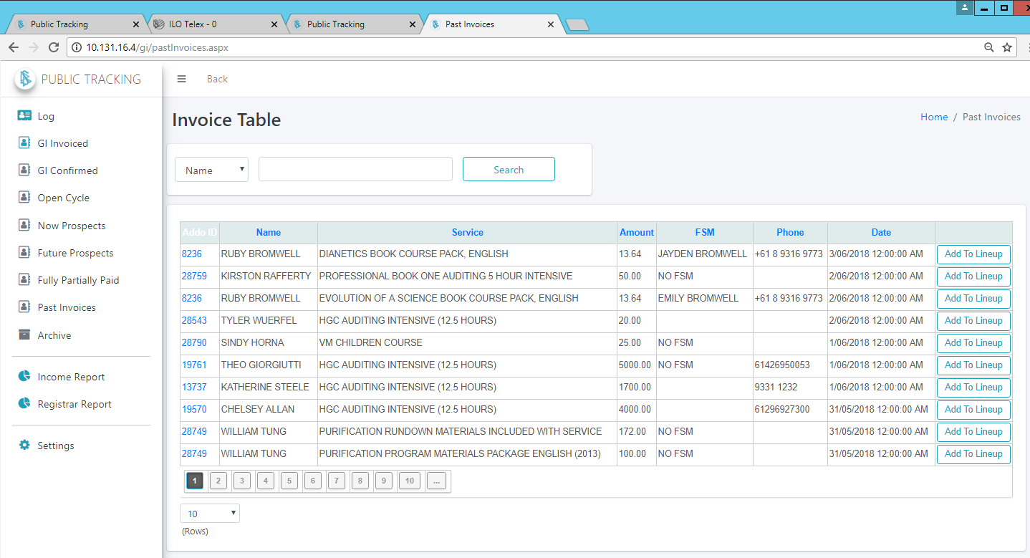

## Archive the Week

At the end of each week after 2pm verify the total in the log matches your Invoiced Income in the Finance System and then Archive this data and start a new week. (As this log is mainly for Department 6 Income, you can make one entry of Div 6 GI or Misc GI so you ensure the total being archived matches the total in the finance system.)

In order to archive the week, ensure you have filled in data for the Name, Amount, Service, Reg and Invoice Date columns. Then select the weekending date and click “Archive Week”. Do this for both Day and Foundation if you are not viewing all combined.)

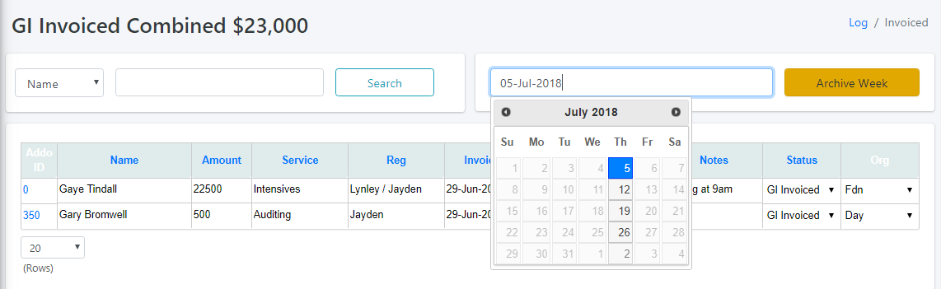

## Setup Registrars

To set up the default registrars that will show up in picklists click on the gear icon at the top right of any page. Set up the registrars for both Day and Fdn using their first name. This will be used for picklists and graphs that are automatically generated for each registar setup here.

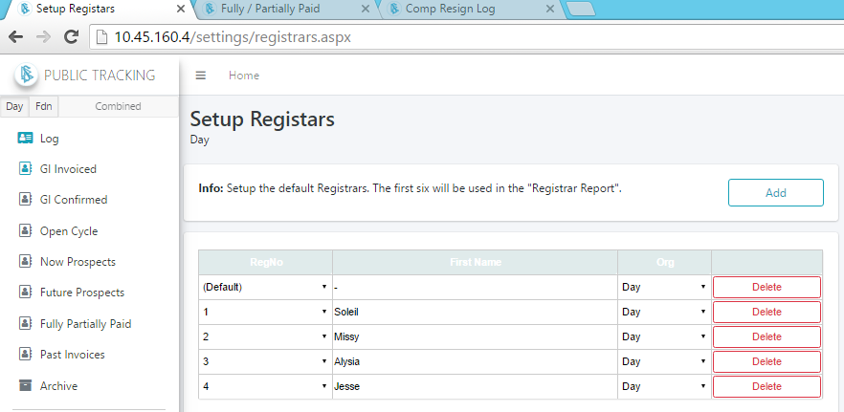

## Income Report

The Income Report gives you a rapid visual view of the Income of the org. Here you can see the Daily graph showing Invoiced and Confirmed income compared to last week, a Weekly Graph over the last several weeks, Pie Charts showing a breakdown by Procurement Line for the current week, last week and all time as well as Weekly Graphs showing the Income from each one of these Procurement Lines.

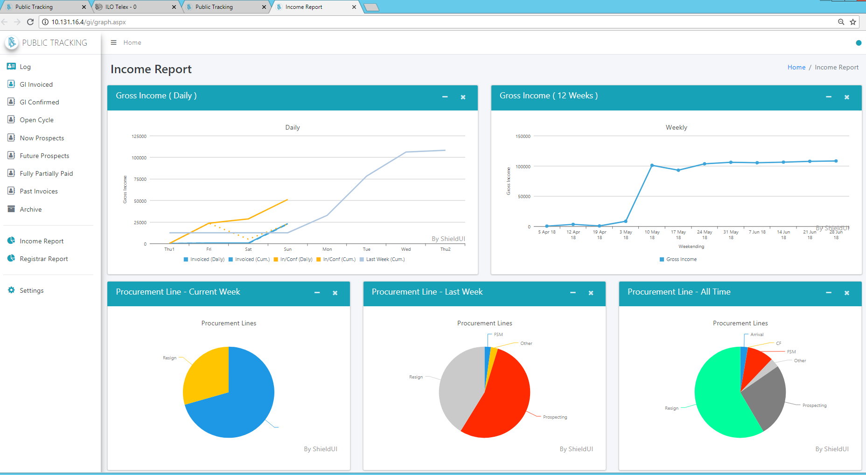

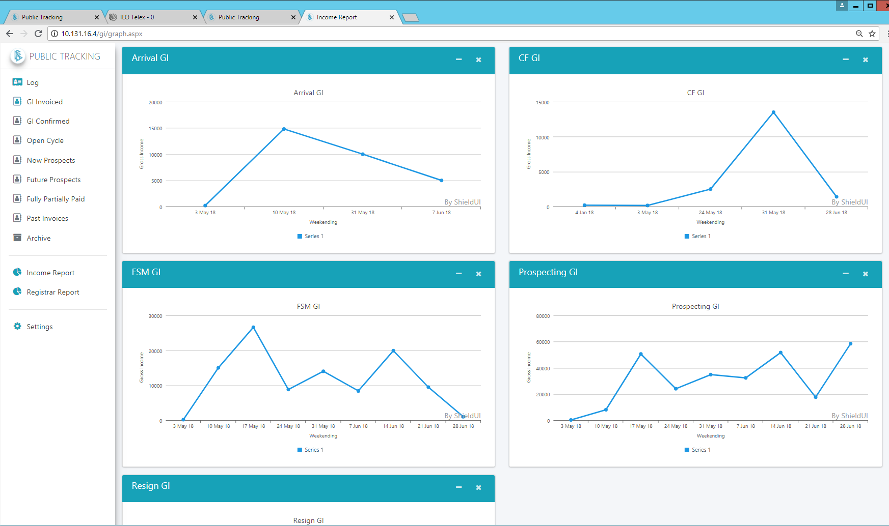

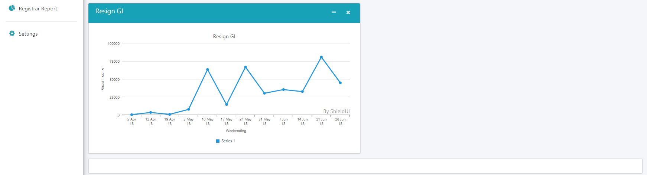

## Registrar Report

The Registrar Report shows graphical and statistical data for each of the Registrars. Here you will quickly see who is producing what their Daily and Weekly Statistics look like as well as a breakdown of what Procurement Line each Registrar is getting their income from. (Setup Registrars in the Home Page / Settings / Setup Registar option).

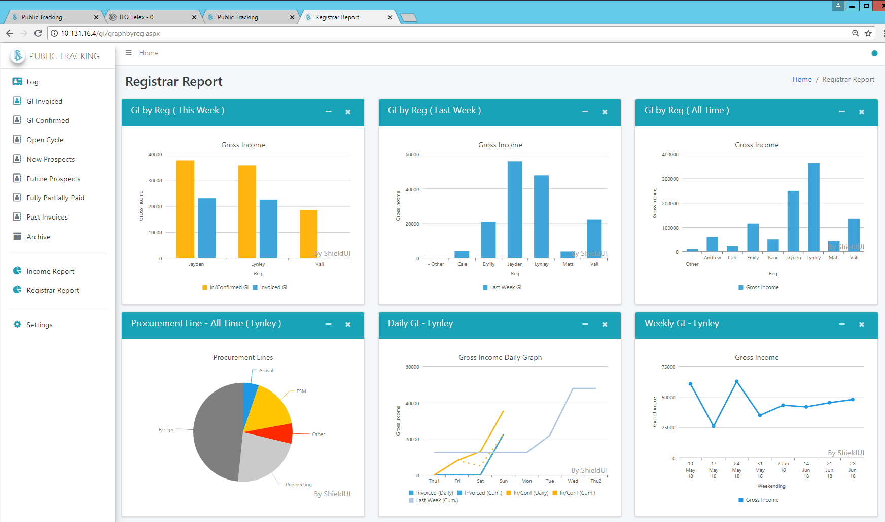

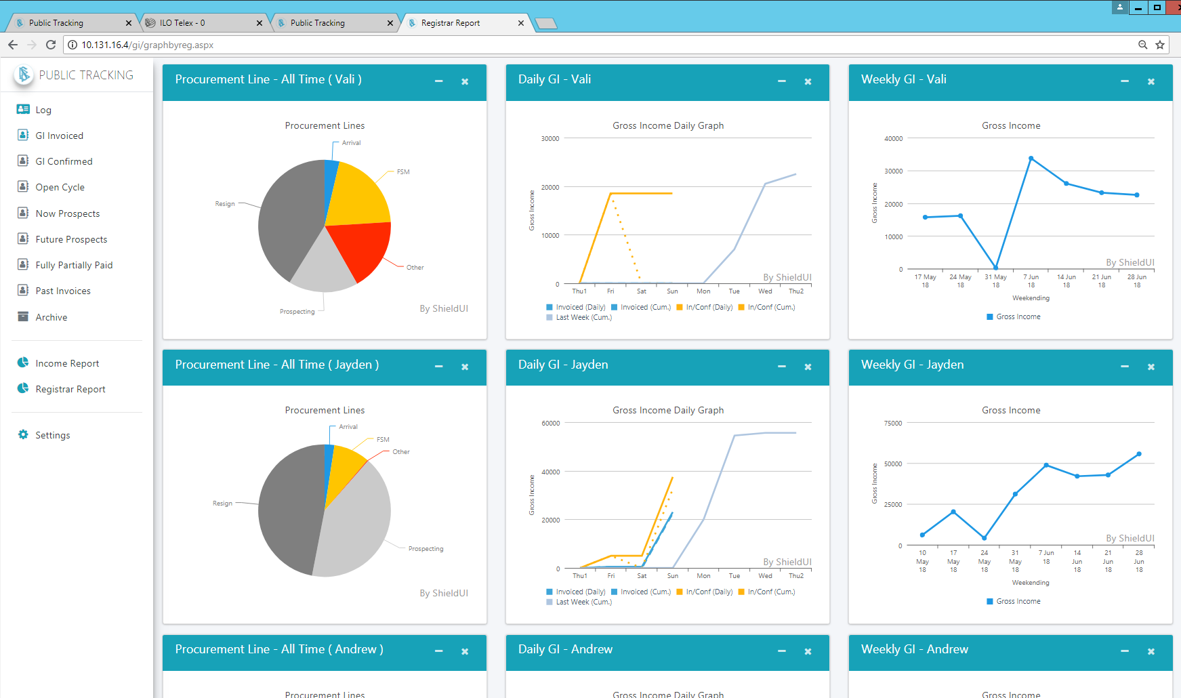

# Service Call-in Committee

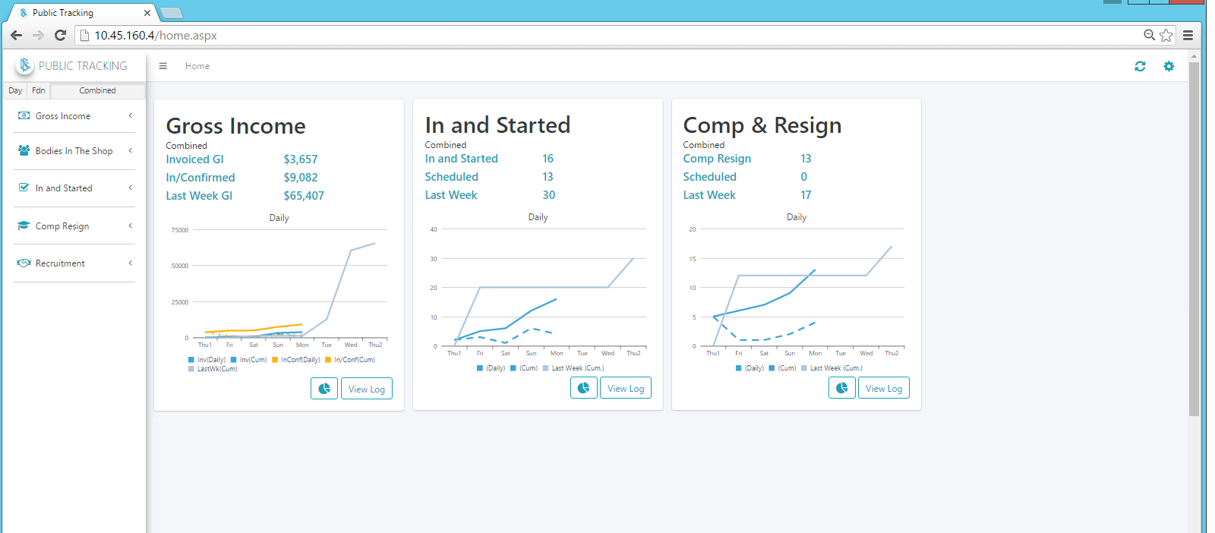

The Service Call-in Committee view assists you to get in the coordination directed in HCO PL 9 AUG 1979 III, SERVICE CALL-IN COMMITTEE, where LRH states:

***“The committee meets daily off production hours and battle plans out all actions needed to get products flowing in each area of promotion, sales, call-in, delivery and re-sign. The specific products are fully listed out in HCO PL 9 Aug. 79 II, SERVICE PRODUCT OFFICER. They ensure the products they are going to get are known and the ‘figure out how to do’ has been done and is coordinated. When this is done each committee member knows what his or her part is in getting out the products. For instance, the Director of Training knows he will have a student graduating shortly, and that this student will need to go on the re-sign line. Therefore the D of T informs the HES at the meeting who takes notes and ensures the Dissemination Division correctly handles the re-sign, or the HES may need to get a Tech Estimate from the C/Ses for a registration cycle. The Director of Processing is then alerted to this at the committee, so the cycle will flow smoothly and quickly.”***

Use the GI Log to list out service sales including those arriving for service as well as those needing to re-sign onto further services as covered in the same reference under the section “COMMITTEE RESPONSIBILITIES”:

***“2. The action of selling Scientology services to all new and old public either currently in the org, new to the org or returning to the org.” …***

***“5. The re-signing of all in-the-org public on completion of service.”***

Work out what needs to be done on each one of these public and note this in the GI Log so all concerned are coordinated and with what they need to do, to get that product.

Use the **In and Started Log** to name out all starts for the week and use the **Comp Resign Log** to name out all re-sign products for the week and note what needs to be done including any coordination needed amongst staff to get that product.

## In and Started

The ***In and Started*** module was created to track public who are named, scheduled and who are In and Started for the week. A simple way to add names to the In and Started is by searching for the public in the BIS log and clicking on the  “Add to (Named) In and Started” button or the  “Add to In and Started” button. At the end of the week you can archive the current week and start newly.

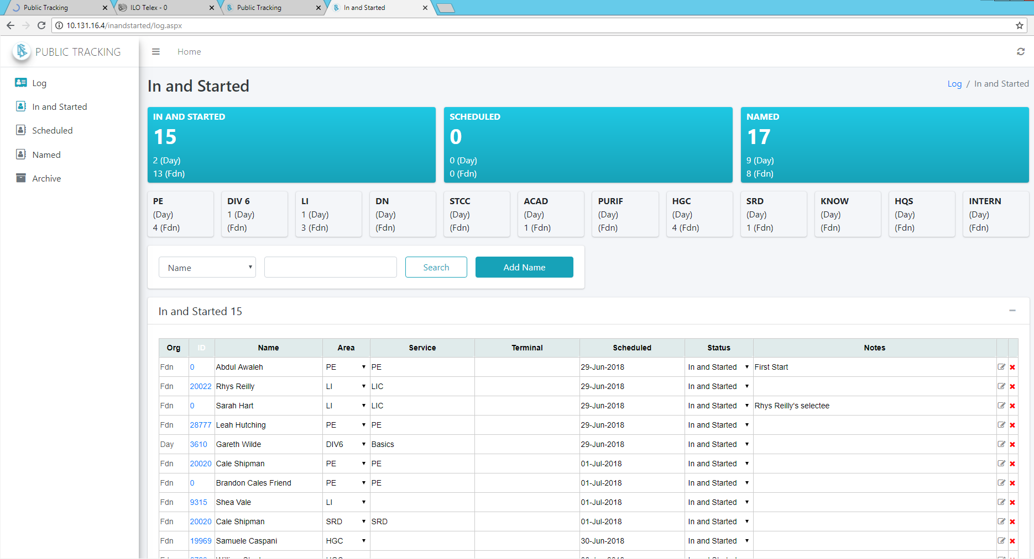

## Archive the Week

At the end of each week after 2pm you can Archive this data and start a new week. In order to archive the week, ensure you have filled in data for the Name, Service Area filled out and then select the weekending date and click “Archive Week”. Do this for both Day and Foundation if you are not viewing all combined.)

## In and Started Report

In this report you can see a breakdown of the current week’s In and Started by Service Area as well as last week’s and of all time. There is also a Daily and a Weekly Graph of the In and Started.

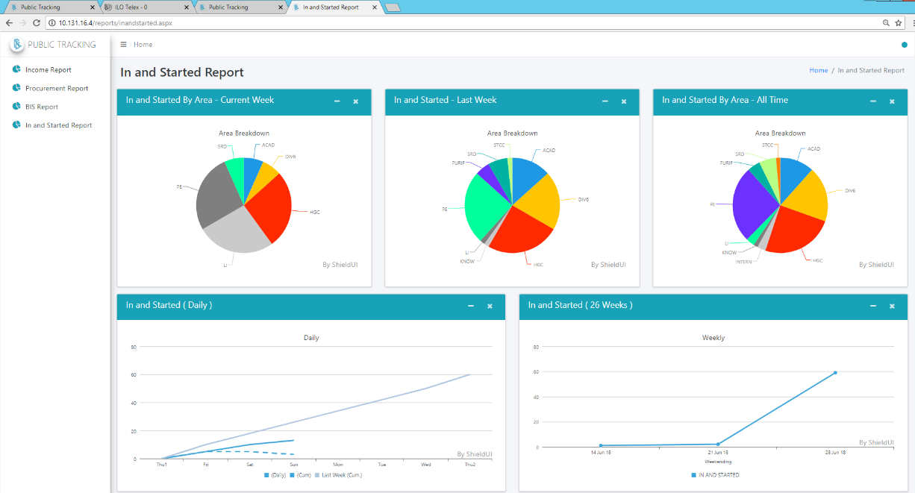

## Comp Resign

The ***Comp Resign*** module was created to track public who are named, scheduled and who are Comp Resign for the week. A simple way to add names to the log is by searching for the public in the BIS log and clicking on the  “Add to (Named) Comp Resign” button or the  “Add to Comp Resign” button. Any completion that failed to Resign is also tracked here so you can handle and get them back onto their next service. At the end of the week you can archive the current week and start newly.

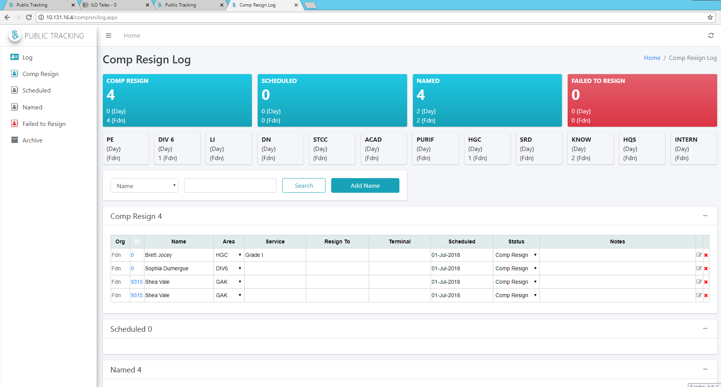

## Archive the Week

At the end of each week after 2pm you can Archive this data and start a new week. In order to archive the week, ensure you have filled in data for the Name, Service Area filled out and then select the weekending date and click “Archive Week”. Do this for both Day and Foundation if you are not viewing all combined.)

## Comp Resign Report

In this report you can see a breakdown of the current week’s Comp Resign by Service Area as well as last week’s and of all time. There is also a Daily and a Weekly Graph of the Comp Resign.

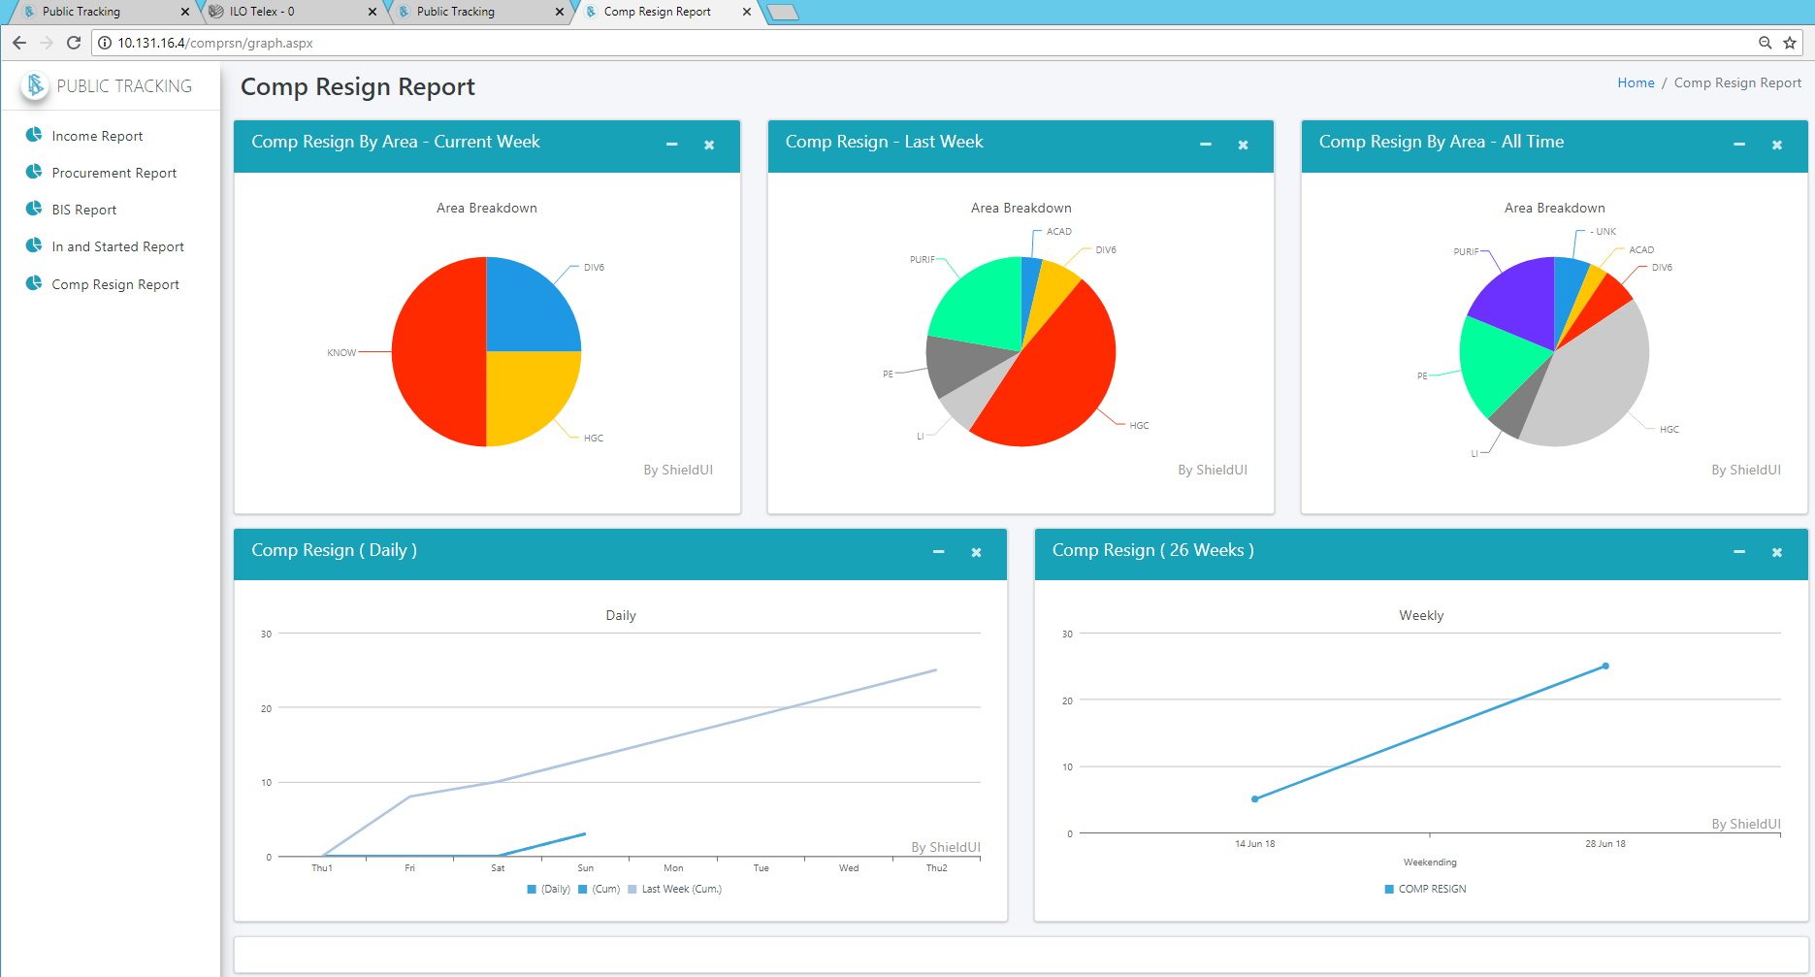

# Bodies In The Shop

(Being integrated with the existing Attendance Log)

The ***Bodies In The Shop*** module was created to help track all bodies in the shop and to prevent public from falling off of service lines. Here you can schedule public and log when they are meant to come into the org, whether for the current week or future weeks. You can also see who was BIS last week who is not yet BIS this week. This is categorized as ***Fallen Off BIS*** and makes it easy to contact each of these and get them back into the org on service.

Each BIS is tracked by Service Area. This way each area can put control in on the public and ensure they continue moving on their services and up the Bridge.

At the end of each week you can archive the current week’s BIS and have a record of who was BIS each week in the past. When the current week is being archived, a copy of all of these names is also added to the “Fallen Off BIS” category for the current week by Service Area.

From the BIS log you can add public to the In and Started log or the Comp Resign log by clicking on the icon at the right of the Notes as you can see below.

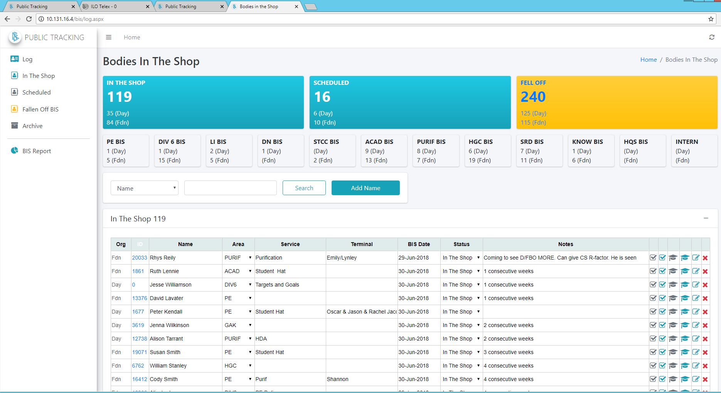

## Archive the Week

At the end of each week after 2pm you can Archive this data and start a new week. In order to archive the week, ensure you have filled in data for the Name, Service Area filled out and then select the weekending date and click “Archive Week”. Do this for both Day and Foundation if you are not viewing all combined.)

## Bodies in the Shop Report

In this report you can see a breakdown of the current week’s BIS by Service Area as well as last week’s and of all time. There is also a Daily and a Weekly Graph of the BIS.

